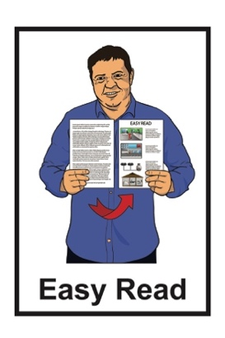


How to use less

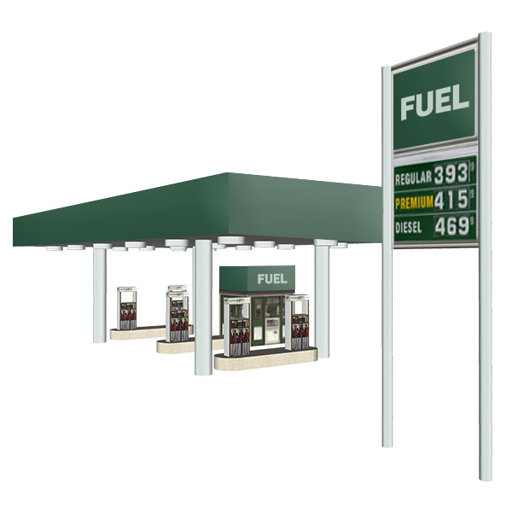
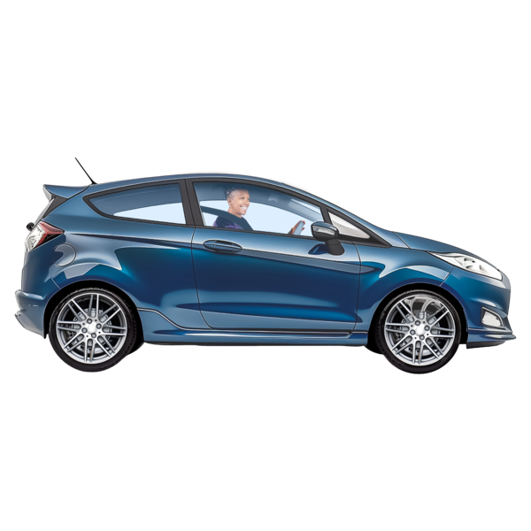
fuel when you drive

Published: April 2026

About this Easy Read

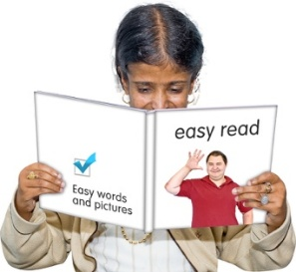
This Easy Read is from the
Energy Efficiency and Conservation Authority.


The Energy Efficiency and Conservation Authority is also called EECA.


EECA is a government organisation that gives advice on the ways people can:
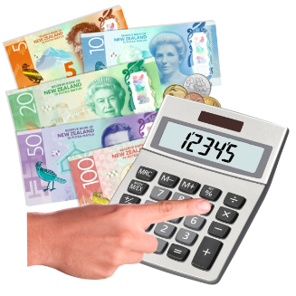
- use energy well
- save money when using energy.

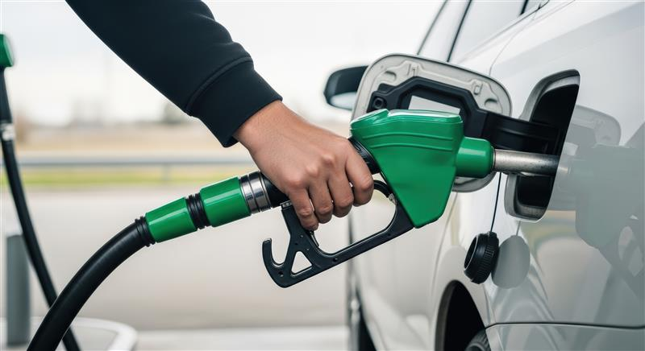
Here energy means things like:
- fuel such as:
  - petrol
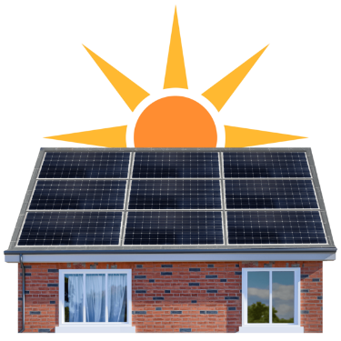
  - diesel
- electricity
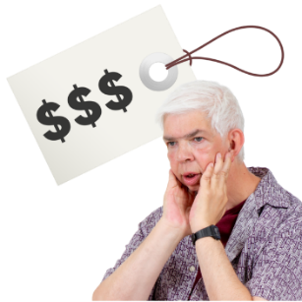
- solar power.

Sometimes fuel can cost a lot of money.
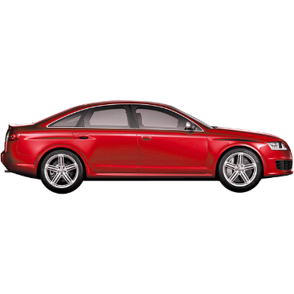

This can make it hard for people to travel to where they need to go.

This Easy Read has some ideas about ways to use less fuel when you drive.

Ways you can use less fuel when driving
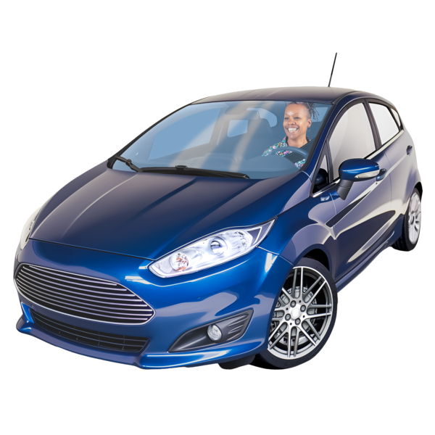
- Look after your car well

A well looked after car:

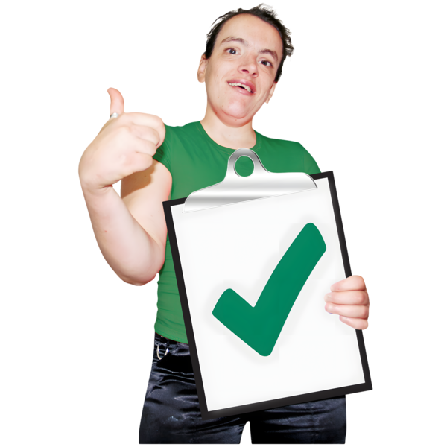
- uses less fuel

- is safer to drive

- lasts longer.
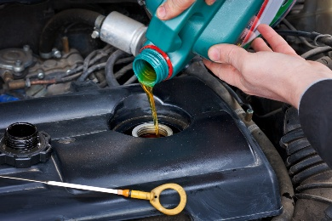

Change oil / air filters when needed.

- Drive smoothly
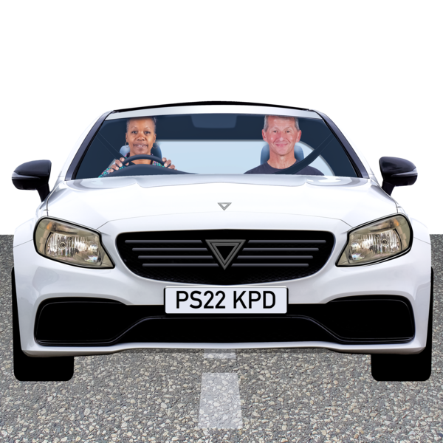
Take your time speeding up to the road speed limit.

Slow down early instead of braking hard.
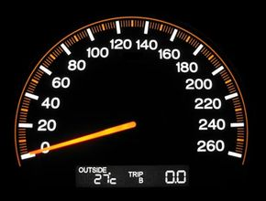
- Watch your speed

Driving fast uses more fuel.

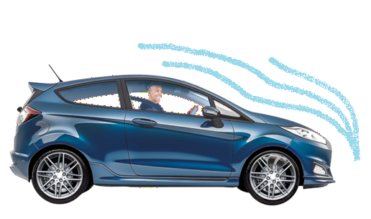
This is because air pushes harder against the car.

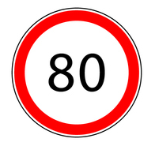
Fuel use goes up a lot once you driver faster than 80 km an hour.

Driving slower can save fuel.
- Carry less things / weight in your car

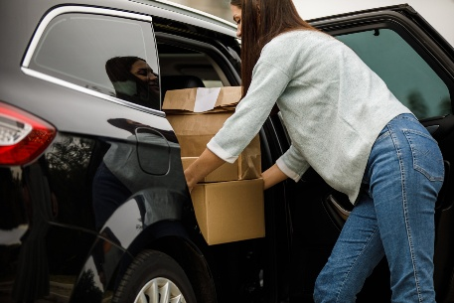
Extra things / weight makes your car harder to move.

Check inside your car for heavy items you do not need.
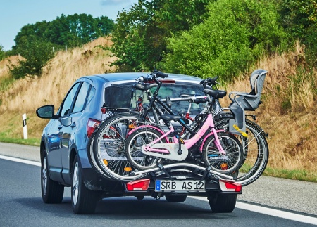
Other things that can weigh down
your car down are:

- roof racks
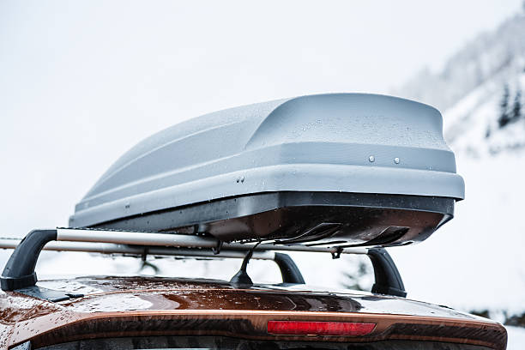
- bike racks

- roof top boxes.

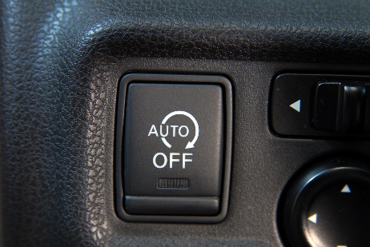
- Turn off your car engine when waiting

If your car has auto-start make sure it is working.

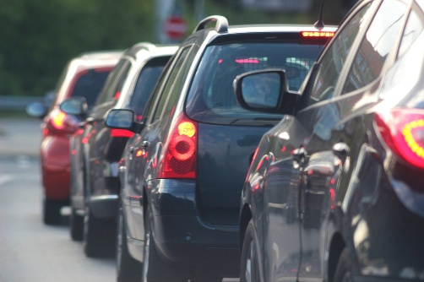
Auto-start stops car engine when it is not moving.

For example your engine stops when you are waiting at the traffic lights.

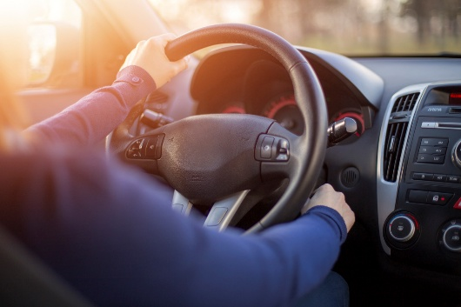
If you do not have auto-start you can turn off car engine to save fuel if you stop for more than 30 seconds.

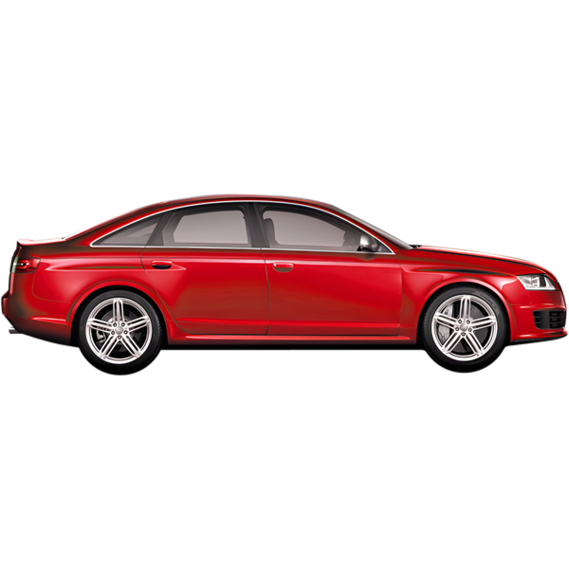
Only turn off your car engine if it is safe to do so.

- Check your car tyres

Tyres slowly lose air over time.

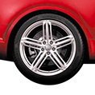
When tyres have less air this is called low tyre pressure.

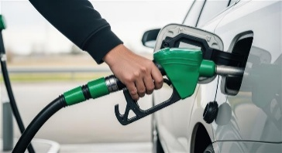
Your car uses more fuel when the tyres have low pressure.

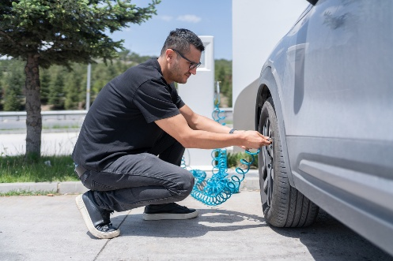
Check your car tyres each month.

You can find instructions inside the driver’s door on how to check your car tyres pressure.

More information

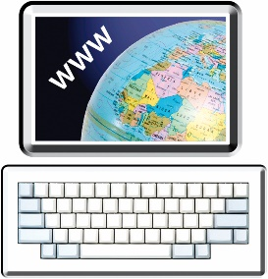
You can find more information about ways to save fuel on the EECA website:

www.eeca.govt.nz


This information has been written by Energy Efficiency and Conversation Authority.


It has been translated into Easy Read by the Make it Easy Kia Māmā Mai service of People First New Zealand Ngā Tāngata Tuatahi.

The ideas in this document are not the ideas of People First New Zealand Ngā Tāngata Tuatahi.
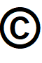
All images used in this Easy Read document are subject to copyright rules and cannot be used without permission.


Make it Easy uses images from:


- Photosymbols

- Change Images

- Huriana Kopeke-Te Aho



- SGC Image Works

- T Wood

- Studio Rebeko


- Inga Kramer

- iStock.

